***Practical 5***

**Aim:** *Implement decision tree learning algorithm for the restaurant waiting problem.*

***Theory:***

*Decision Tree is one of the most powerful and popular algorithms. Decision-tree algorithm falls under the category of supervised learning algorithms. It works for both continuous as well as categorical output variables.*

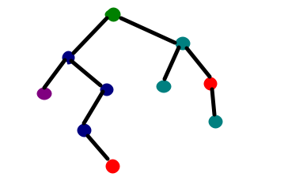

***Assumptions we make while using Decision tree :***

* *At the beginning, we consider the whole training set as the root.*
* *Attributes are assumed to be categorical for information gain and for gini index, attributes are assumed to be continuous.*
* *On the basis of attribute values records are distributed recursively.*
* *We use statistical methods for ordering attributes as root or internal node.*

***Pseudocode :***

* 1. *Find the best attribute and place it on the root node of the tree.*
  2. *Now, split the training set of the dataset into subsets. While making the subset make sure that each subset of training dataset should have the same value for an attribute.*
  3. *Find leaf nodes in all branches by repeating 1 and 2 on each subset.*

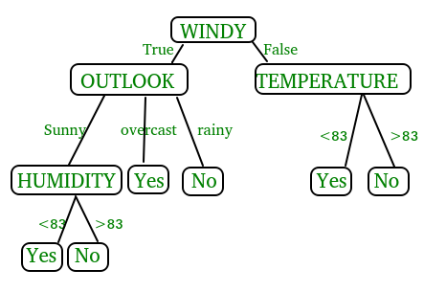

*While implementing the decision tree we will go through the following two phases:*

* 1. *Building Phase*
     + *Preprocess the dataset.*
     + *Split the dataset from train and test using Python sklearn package.*
     + *Train the classifier.*
  2. *Operational Phase*
     + *Make predictions.*
     + *Calculate the accuracy.*

***Data Import :***

* *To import and manipulate the data we are using the pandas package provided in python.*
* *Here, we are using a URL which is directly fetching the dataset from the UCI site no need to download the dataset. When you try to run this code on your system make sure the system should have an active Internet connection.*
* *As the dataset is separated by “,” so we have to pass the sep parameter’s value as “,”.*
* *Another thing is notice is that the dataset doesn’t contain the header so we will pass the Header parameter’s value as none. If we will not pass the header parameter then it will consider the first line of the dataset as the header.*

***Data Slicing :***

* *Before training the model we have to split the dataset into the training and testing dataset.*
* *To split the dataset for training and testing we are using the sklearn module train_test_split*
* *First of all we have to separate the target variable from the attributes in the dataset.*

X = balance_data.values[:, 1:5]

Y = balance_data.values[:,0]

* *Above are the lines from the code which separate the dataset. The variable X contains the attributes while the variable Y contains the target variable of the dataset.*
* *Next step is to split the dataset for training and testing purpose.*

X_train, X_test, y_train, y_test = train_test_split(

X, Y, test_size = 0.3, random_state = 100)

* *Above line split the dataset for training and testing. As we are splitting the dataset in a ratio of 70:30 between training and testing so we are pass test_size parameter’s value as 0.3.*
* *random_state variable is a pseudo-random number generator state used for random sampling.*

***Terms used in code :***

*Gini index and information gain both of these methods are used to select from the n attributes of the dataset which attribute would be placed at the root node or the internal node.*

***Gini index:***

**

* *Gini Index is a metric to measure how often a randomly chosen element would be incorrectly identified.*
* *It means an attribute with lower gini index should be preferred.*
* *Sklearn supports “gini” criteria for Gini Index and by default, it takes “gini” value.*

***Entropy:***

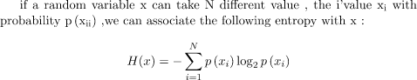

* *Entropy is the measure of uncertainty of a random variable, it characterizes the impurity of an arbitrary collection of examples. The higher the entropy the more the information content.*

***Information Gain***



* *The entropy typically changes when we use a node in a decision tree to partition the training instances into smaller subsets. Information gain is a measure of this change in entropy.*
* *Sklearn supports “entropy” criteria for Information Gain and if we want to use Information Gain method in sklearn then we have to mention it explicitly.*

***Accuracy score***

* *Accuracy score is used to calculate the accuracy of the trained classifier.*

***Confusion Matrix***

* [*Confusion Matrix*](https://www.geeksforgeeks.org/confusion-matrix-machine-learning/)*is used to understand the trained classifier behavior over the test dataset or validate dataset.*

***Code:***

import numpy as np

import pandas as pd

import sklearn as sk

from sklearn.metrics import confusion_matrix

from sklearn.model_selection import train_test_split

from sklearn.tree import DecisionTreeClassifier

from sklearn.metrics import accuracy_score

from sklearn.metrics import classification_report

#func importing dataset

def importdata():

      balance_data=pd.read_csv("balance-scale.data")

      #print the dataset shape

      print("Dataset Length : ",len(balance_data))

      #printing the dataset observations

      print("Dataset : ",balance_data.head())

      return balance_data

#func to split the dataset

def splitdataset(balance_data):

      #seperating the target variable

      X=balance_data.values[:,1:5]

      Y=balance_data.values[:,0]

      #splitting the dataset into train and test

      X_train,X_test,y_train,y_test=train_test_split(X,Y,test_size=0.3,random_state=100)

      return X,Y,X_train,X_test,y_train,y_test

#function to perform training with entropy

def train_using_entropy(X_train,X_test,y_train,y_test):

      #decision tree with entropy

      clf_entropy=DecisionTreeClassifier(criterion="entropy",random_state=100,max_depth=3,min_samples_leaf=5)

      #performing training

      clf_entropy.fit(X_train,y_train)

      return clf_entropy

def prediction(X_test,clf_object):

      y_pred=clf_object.predict(X_test)

      print("Predicted Values : ")

      print(y_pred)

      return y_pred

def cal_accuracy(y_test,y_pred):

      print("Accuracy : ",accuracy_score(y_test,y_pred)*100)

def main():

      data=importdata()

      X,Y,X_train,X_test,y_train,y_test=splitdataset(data)

      clf_entropy=train_using_entropy(X_train,X_test,y_train,y_test)

      print("Results using entropy : ")

      y_pred_entropy=prediction(X_test,clf_entropy)

      cal_accuracy(y_test,y_pred_entropy)

main()

***balance-sheet.data***

B,1,1,1,1

R,1,1,1,2

R,1,1,1,3

R,1,1,1,4

R,1,1,1,5

R,1,1,2,1

R,1,1,2,2

.

.

.L,5,5,4,5

L,5,5,5,1

L,5,5,5,2

L,5,5,5,3

L,5,5,5,4

B,5,5,5,5

***Output:***

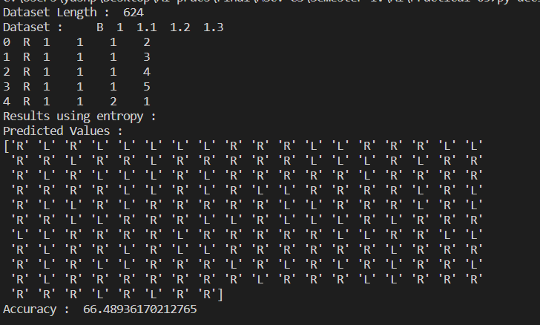

***Conclusion:***

*Implemented decision tree learning algorithm for the restaurant waiting problem.*